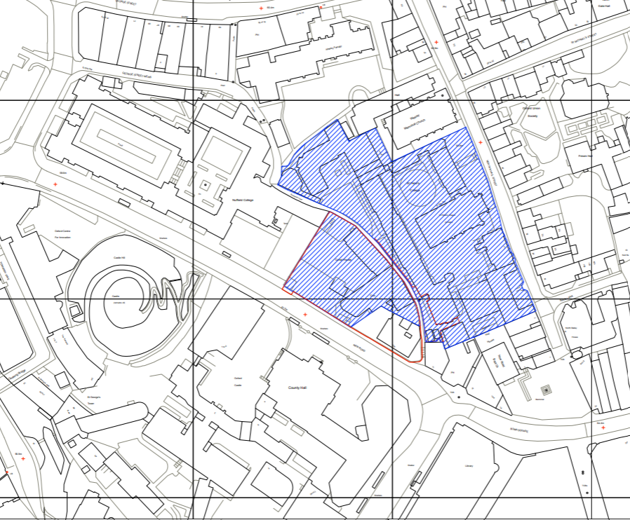
Appendix 1 – Location Plan (19/02306/FUL) Castle Hill House

